EXPT NO: 9 | TEXT CLASSIFICATION AND TEXT GENERATION USING TRANSFORMERS
DATE: 2/11/2026 | TEXT CLASSIFICATION AND TEXT GENERATION USING TRANSFORMERS

PRE-LAB QUESTIONS (PROVIDE BRIEF ANSWERS TO THE FOLLOWING QUESTIONS)

1. What is a Transformer model in Natural Language Processing (NLP)?
A Transformer is a deep learning architecture used in NLP that uses self-attention to understand relationships between words in a sentence. It processes multiple tokens in parallel and captures contextual information efficiently.
Key components:
- Encoder: Processes input text and creates contextual representations.
- Decoder: Generates output text.
- Self-attention: Identifies relationships between words.
- Positional encoding: Provides information about token positions.
Applications: Machine translation, text classification, text summarization, and text generation.
2. What is BERT, and how is it used for text classification?
BERT stands for Bidirectional Encoder Representations from Transformers. It is a pretrained language model developed by Google that understands words by considering both left and right context.
Working:
- Input text is converted into tokens.
- BERT processes the tokens and captures contextual information.
- A classification layer predicts the category.
- The output is assigned a label.
Example: The sentence "This movie is excellent" is classified as Positive Sentiment.
Applications: Sentiment analysis, spam detection, emotion detection, and news classification.
3. What is fine-tuning in the context of pretrained language models?
Fine-tuning is the process of training a pretrained language model further on a task-specific dataset to improve its performance on a particular task.
Steps:
- Select a pretrained model such as BERT.
- Prepare a task-specific dataset.
- Train the model using the dataset.
- Evaluate its performance.
Example: Fine-tuning BERT with labeled emails enables it to classify emails as spam or not spam.
Advantages: Saves training time, requires less data than training from scratch in many cases, and improves task-specific performance.
4. What is the difference between text classification and text generation?
Feature | Text Classification | Text Generation
Definition | Assigns predefined categories to text. | Generates new text based on input or context.
Purpose | Identifies the class or category. | Produces meaningful sentences or paragraphs.
Input | Text or document. | Prompt, text, or context.
Output | A class label or category. | A sequence of words or sentences.
Models | BERT, DistilBERT. | GPT, T5.
Example | Classifying a review as positive or negative. | Generating a review or story.
Applications | Spam detection, sentiment analysis. | Story writing, chatbots, text summarization.
5. What is a sequence-to-sequence model, and how is it used in text generation?
A Sequence-to-Sequence (Seq2Seq) model is a deep learning architecture that converts an input sequence into an output sequence. The input and output may have different lengths.
Main components:
- Encoder: Processes the input sequence and creates contextual representations.
- Decoder: Generates the output sequence one token at a time using the encoded information and previously generated tokens.
Working:
- The encoder processes the input text.
- The decoder uses the encoded information to generate output tokens.
- Tokens are generated sequentially until the output is complete.
Example: English input "How are you?" is translated into Tamil as "நீங்கள் எப்படி இருக்கிறீர்கள்?"
Applications: Machine translation, text summarization, chatbots, and dialogue generation.
Examples of models: Traditional RNN/LSTM-based Seq2Seq models and Transformer-based models such as T5.
AIM
To implement text classification by fine-tuning a pretrained BERT model and develop a simple sequence-to-sequence text generation application using Transformer models.

SOFTWARE REQUIREMENTS
- Python
- Google Colab
- Hugging Face Transformers
- Hugging Face Datasets
- PyTorch
- NumPy
- Pandas
- Matplotlib

OBJECTIVES
Students will be able to:
- Understand the architecture and working of Transformer models in NLP.
- Understand the concepts of text classification and text generation.
- Load and preprocess text datasets for NLP applications.
- Fine-tune a pretrained BERT model for text classification.
- Evaluate the classification model using appropriate performance metrics.
- Implement a sequence-to-sequence application using a pretrained Transformer model.
- Generate text using the model's text generation capabilities.
- Analyze and compare the outputs produced by the Transformer models.

PROCEDURE
PART A: DATASET PREPARATION AND TEXT PREPROCESSING
Perform the following tasks:
- Load a text dataset such as the IMDb movie review dataset.
- Explore the dataset and examine sample text entries and their labels.
- Check the number of samples and the distribution of class labels.
- Separate the dataset into training and testing sets or use the predefined splits.
- Load a pretrained tokenizer corresponding to the BERT model.
- Tokenize the text using the tokenizer.
- Apply padding and truncation to maintain consistent input lengths.
- Convert the tokenized data into the required format for model training.
- Prepare the dataset for batch-wise processing.
PART B: FINE-TUNING BERT FOR TEXT CLASSIFICATION
Perform the following tasks:
- Load a pretrained BERT model for sequence classification.
- Configure the model for the required number of classes.
- Prepare the tokenized training and testing datasets.
- Define the training parameters, including learning rate, batch size, and number of epochs.
- Fine-tune the BERT model using the training dataset.
- Evaluate the trained model using the testing dataset.
- Calculate appropriate performance metrics, such as accuracy, precision, recall, and F1-score.
- Test the model using new text inputs.
- Display the predicted class labels and corresponding evaluation results.
- Save the fine-tuned model and tokenizer.
PART C: IMPLEMENTING A SEQUENCE-TO-SEQUENCE APPLICATION USING TRANSFORMERS
Perform the following tasks:
- Load a pretrained sequence-to-sequence Transformer model, such as T5-small.
- Load the corresponding tokenizer.
- Prepare a sample text input for the selected text generation task.
- Preprocess the input according to the model's requirements.
- Generate output text using the pretrained model.
- Apply appropriate generation parameters, such as maximum output length and beam search, where applicable.
- Display the input text and the generated output.
- Experiment with different input texts and generation settings.
- Observe how changes in the input and generation parameters affect the output.
- Save the generated outputs for further analysis.

PART D: MODEL TESTING AND OUTPUT ANALYSIS
Perform the following tasks:
- Test the fine-tuned BERT model using sample positive and negative text inputs.
- Record the predicted class labels for the test inputs.
- Analyze the classification results using the selected evaluation metrics.
- Test the sequence-to-sequence model using different input texts.
- Compare the generated outputs for different inputs and generation settings.
- Examine the relevance, readability, and coherence of the generated text.
- Identify possible errors or limitations in the classification and generation outputs.
- Compare the applications of BERT-based classification and sequence-to-sequence text generation.
- Summarize the observations obtained from both models.

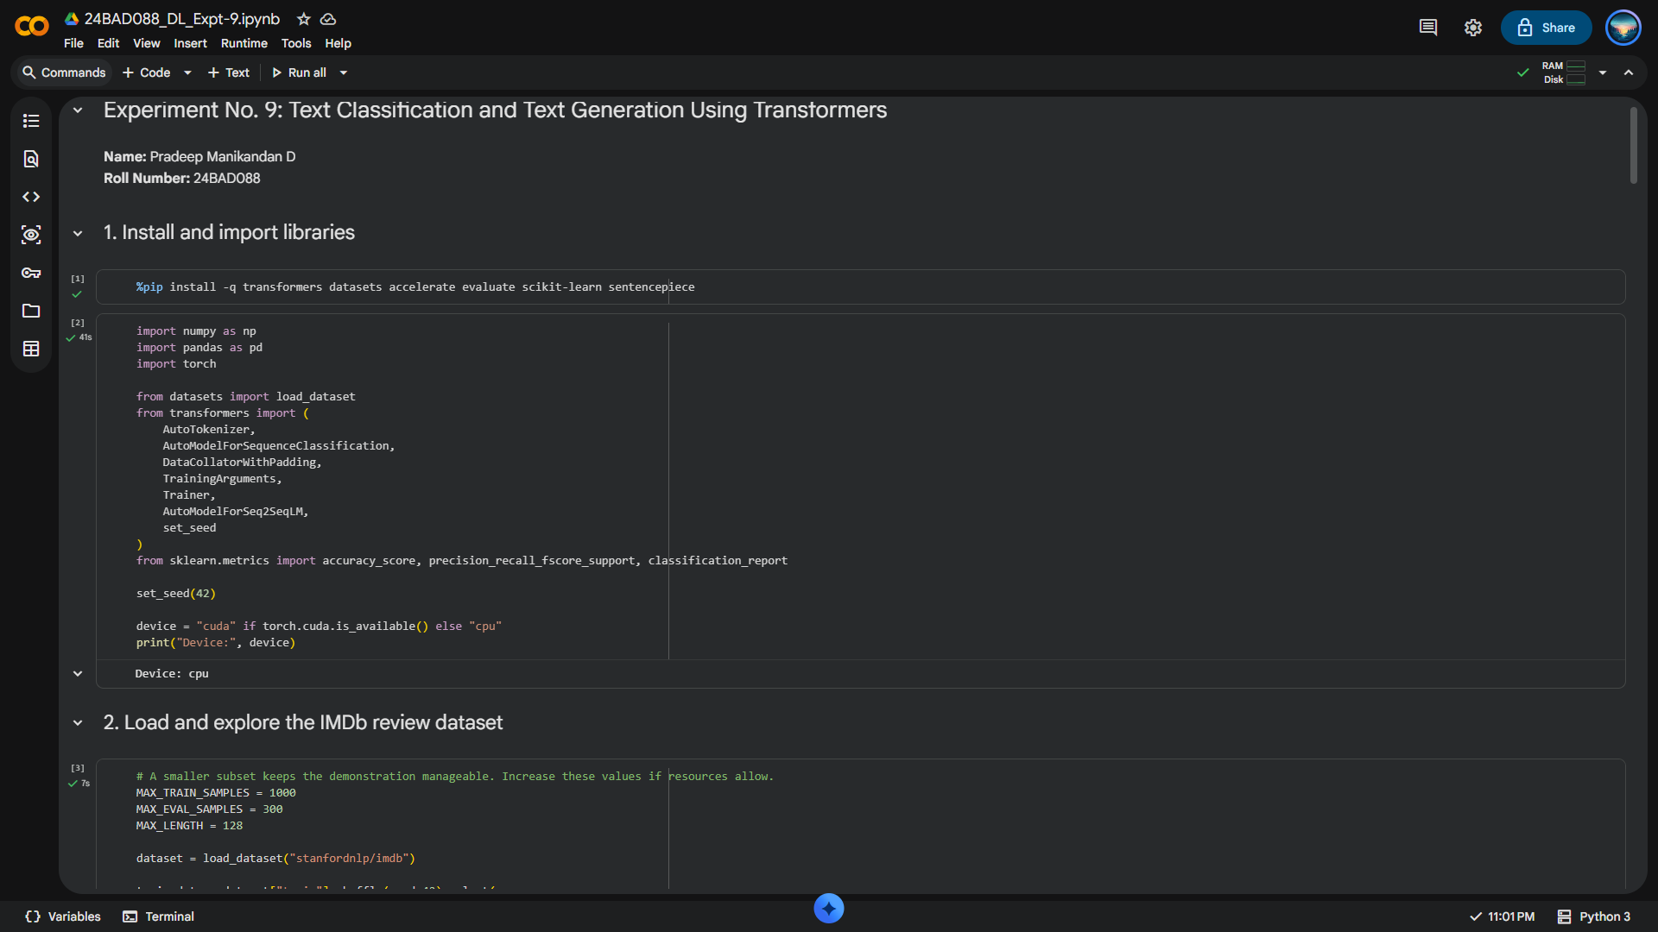
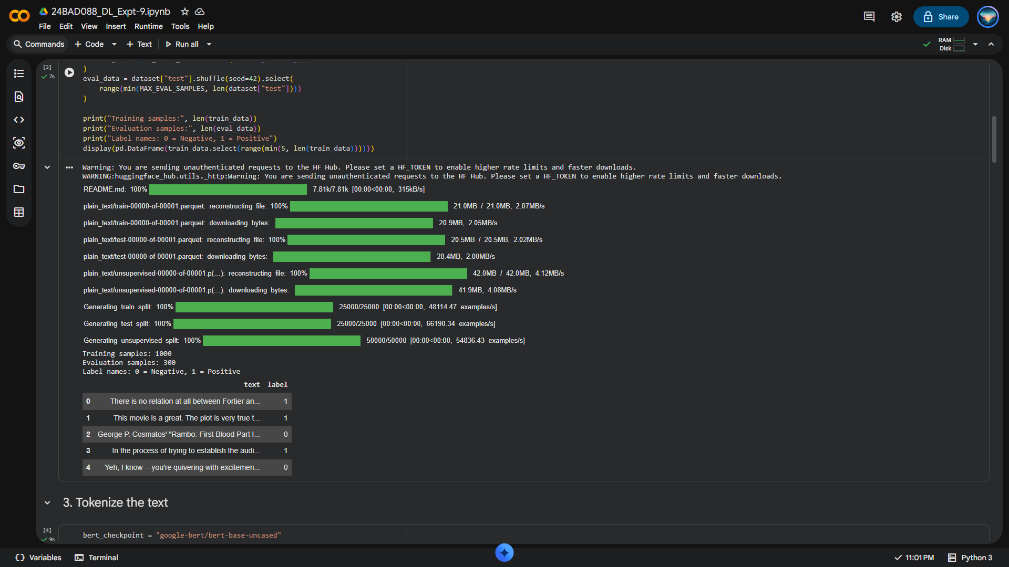
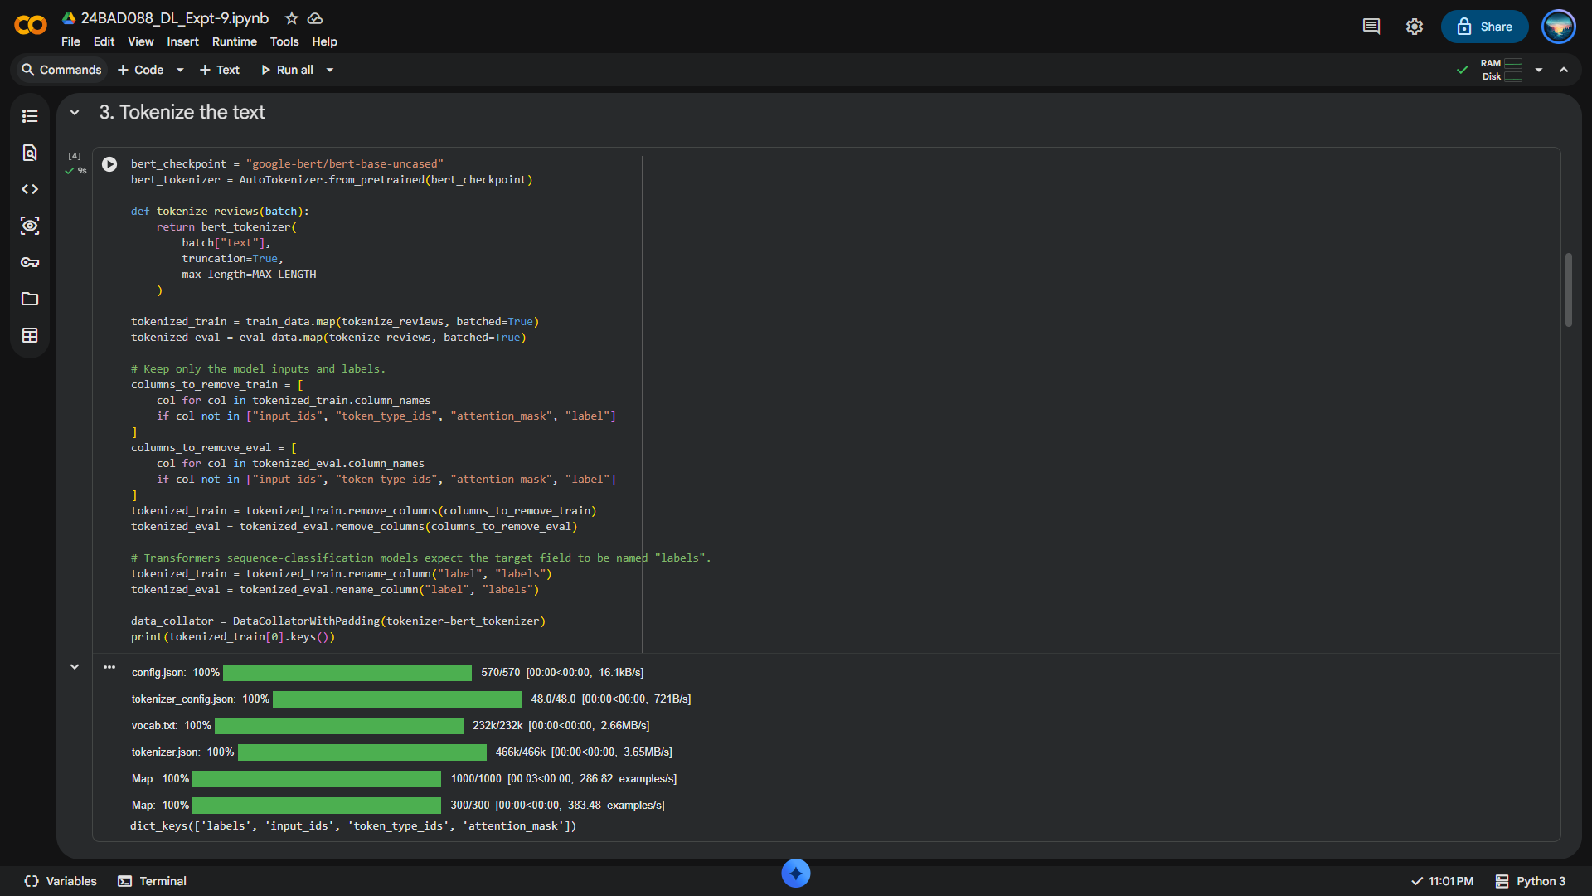
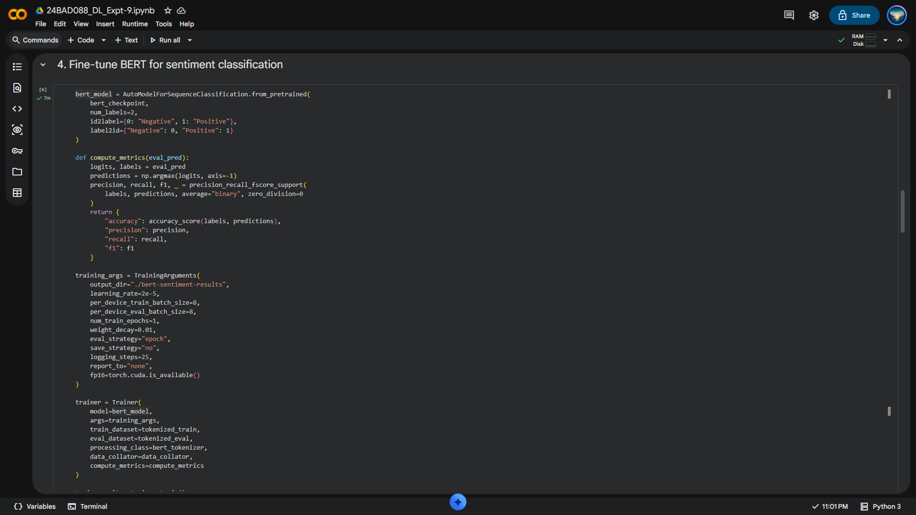
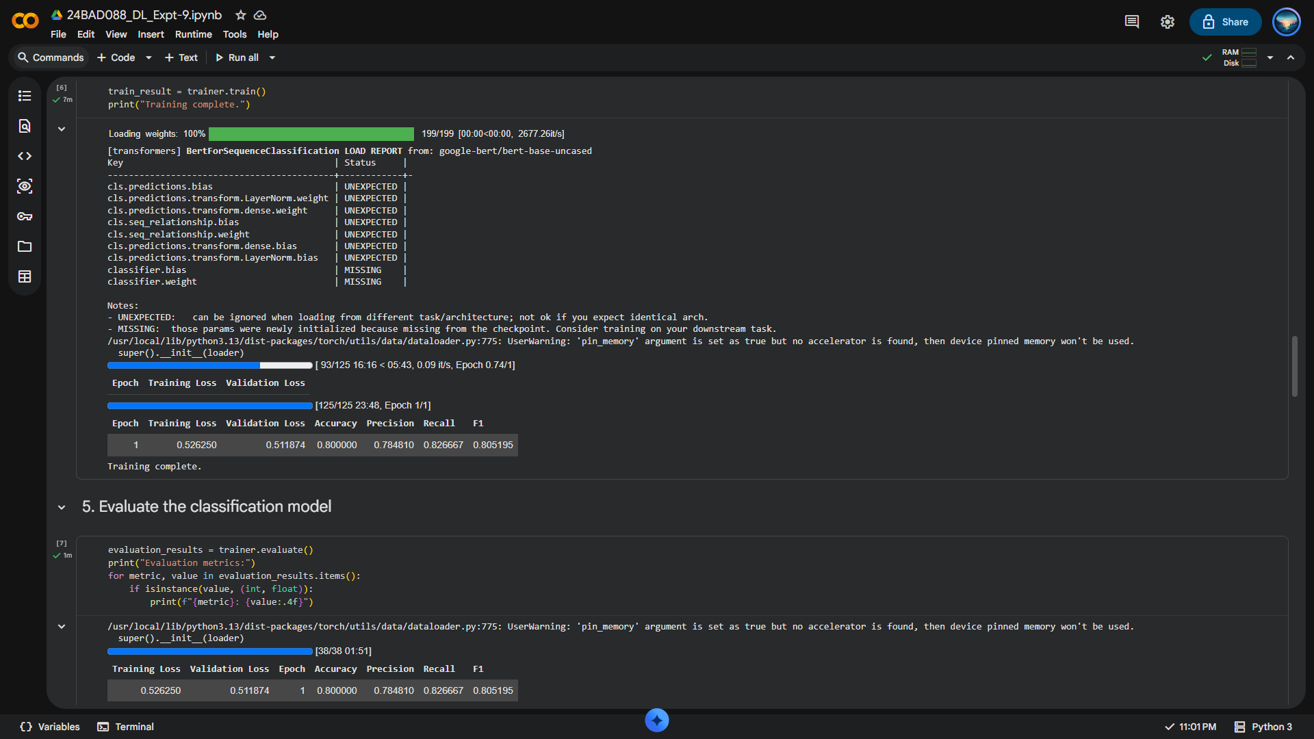
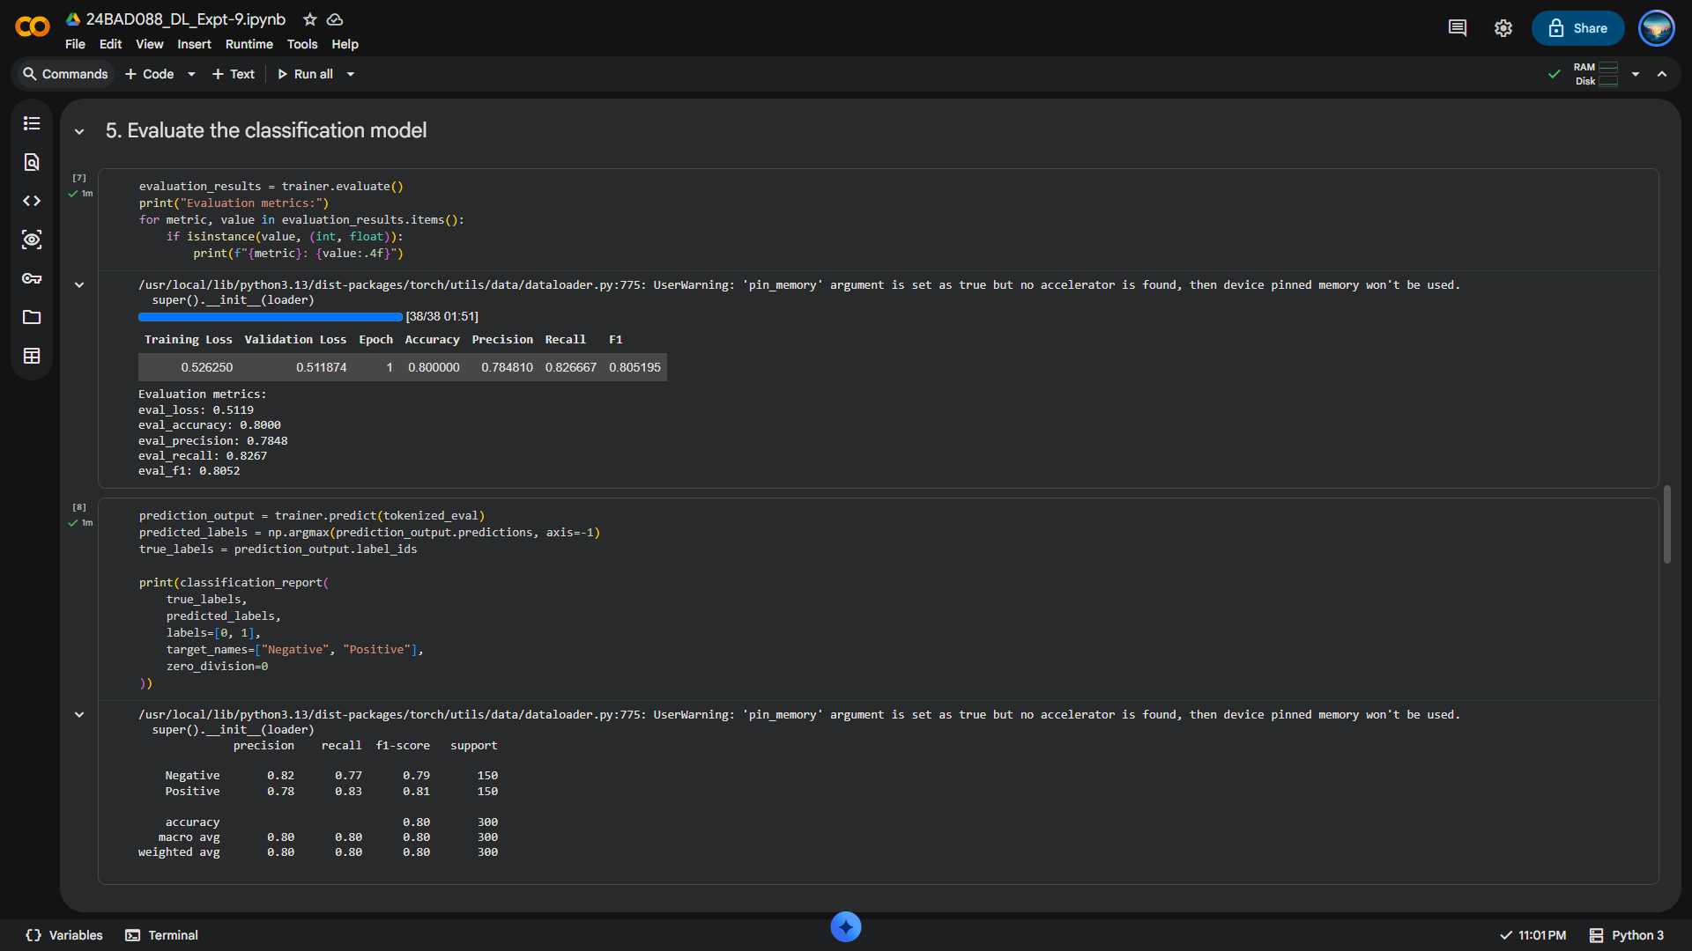
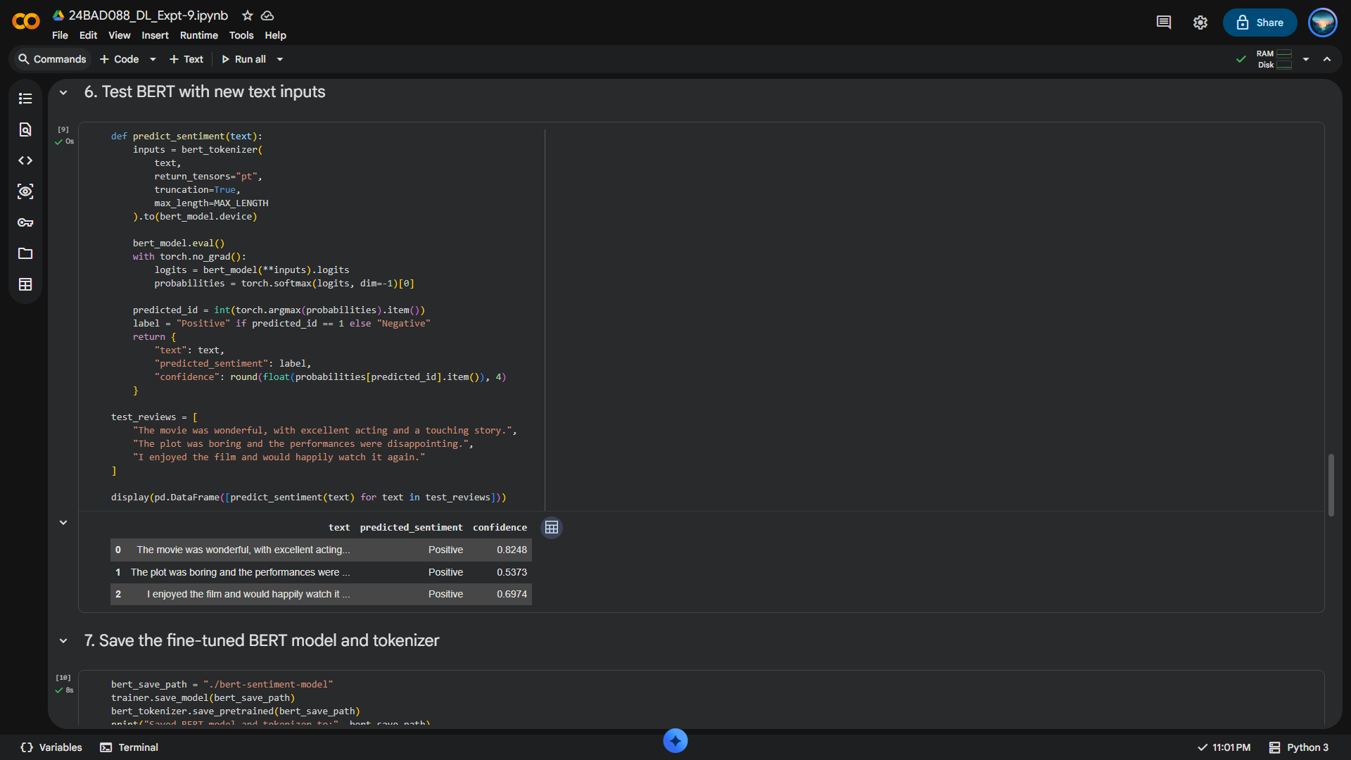
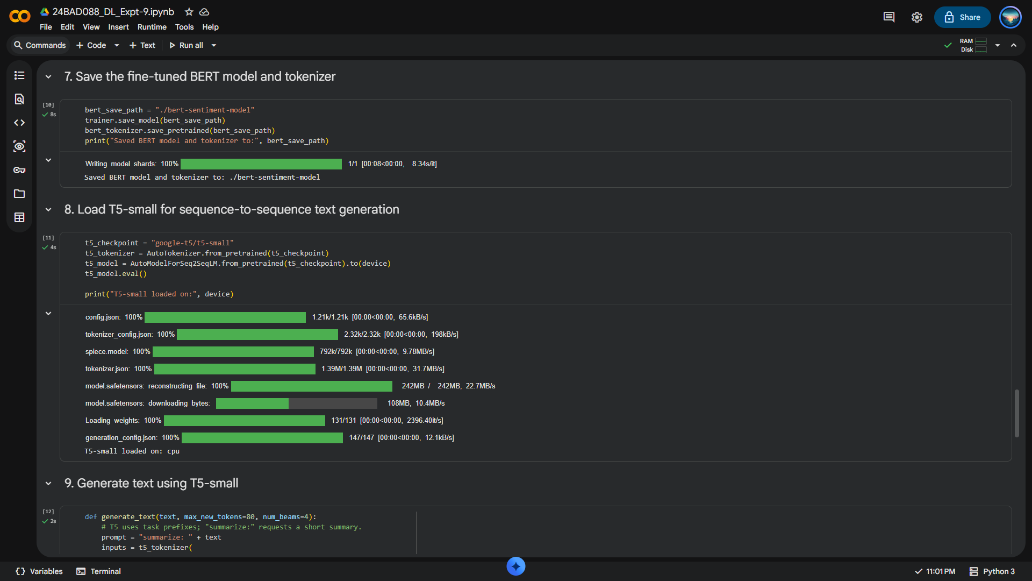
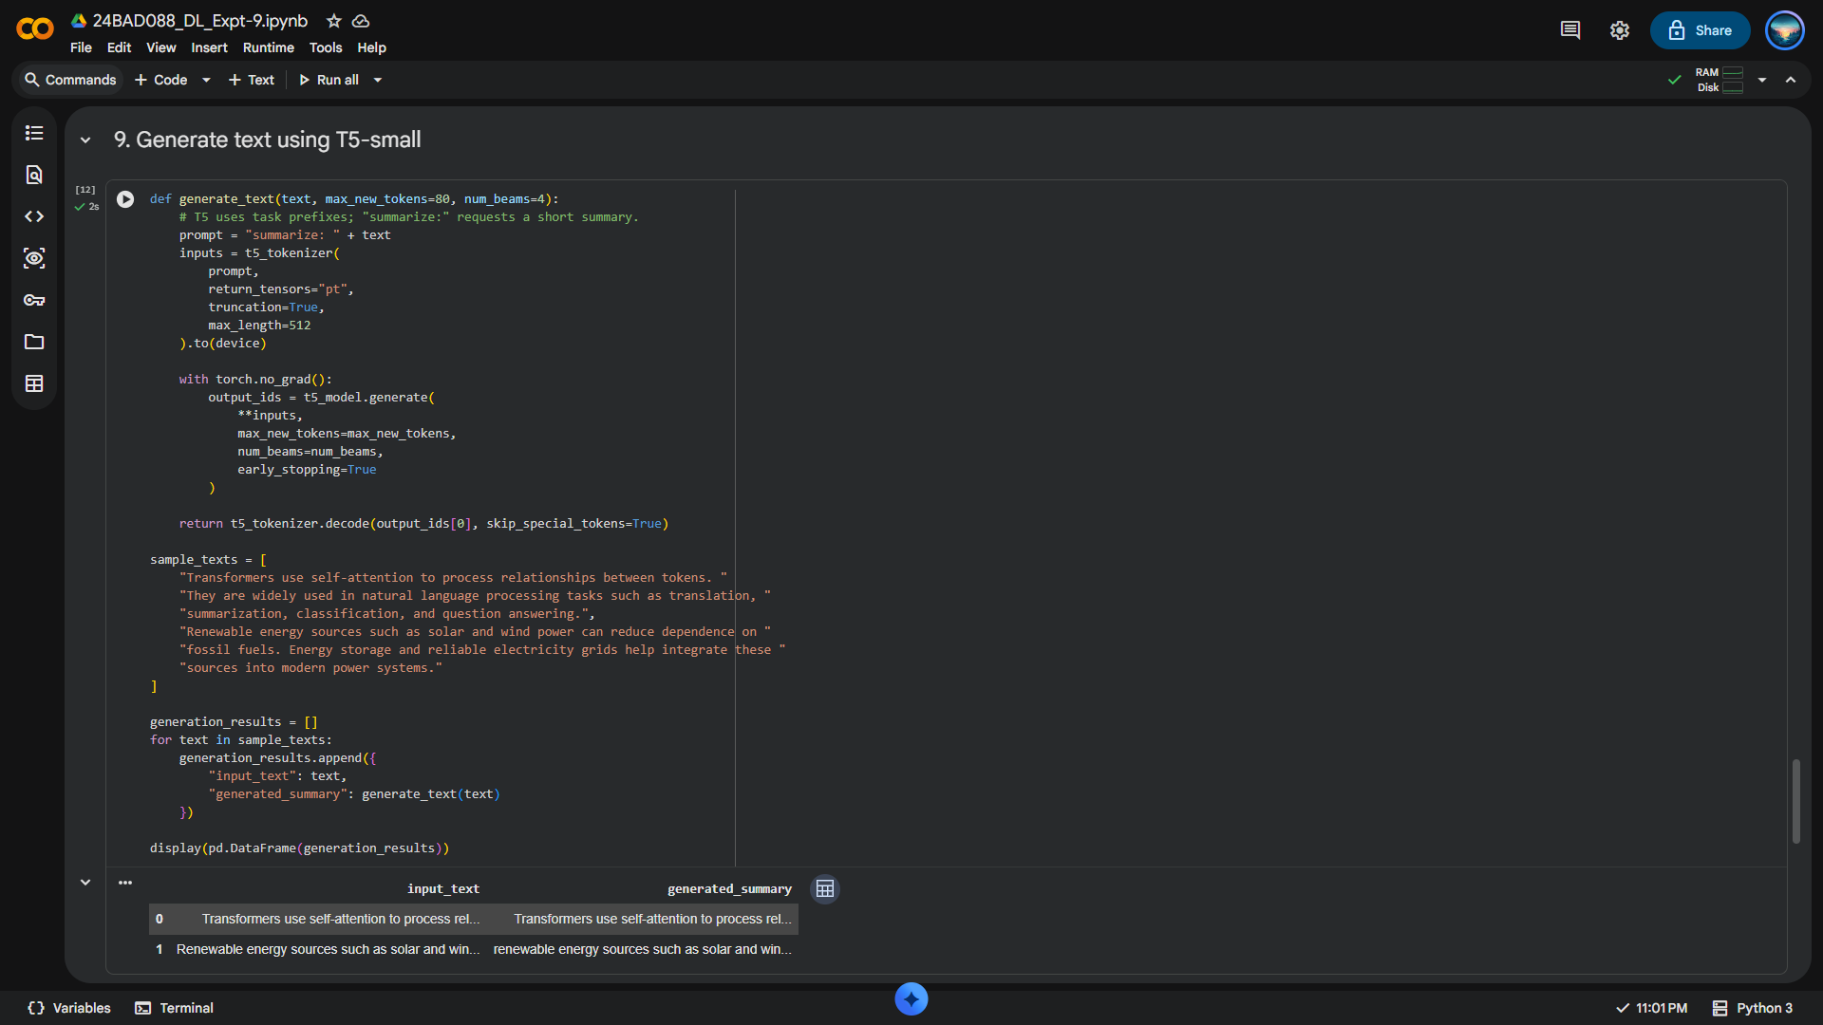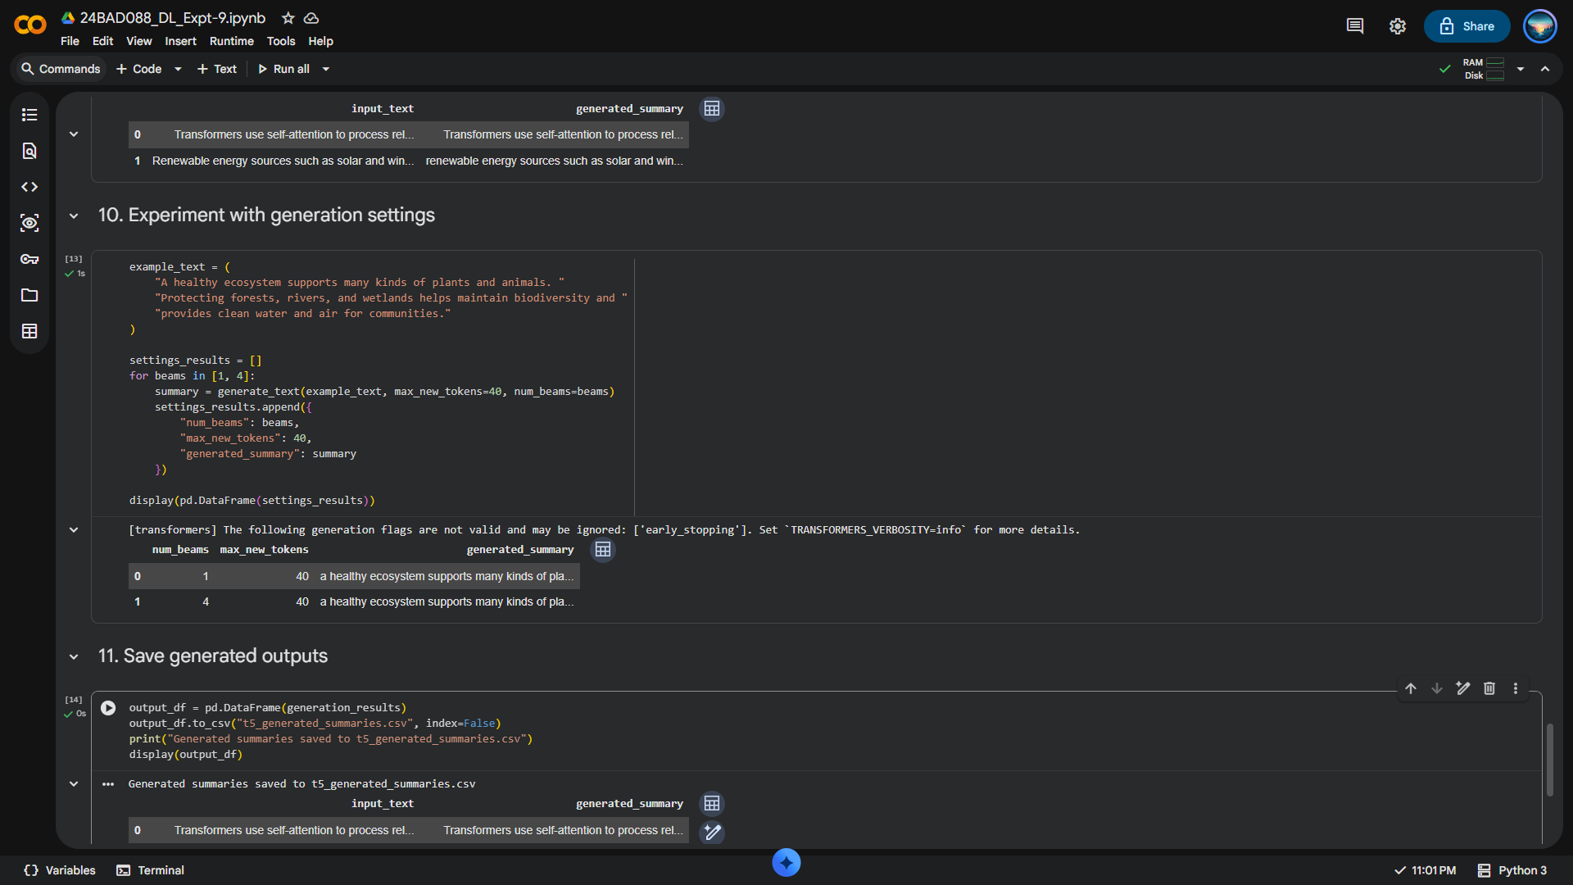
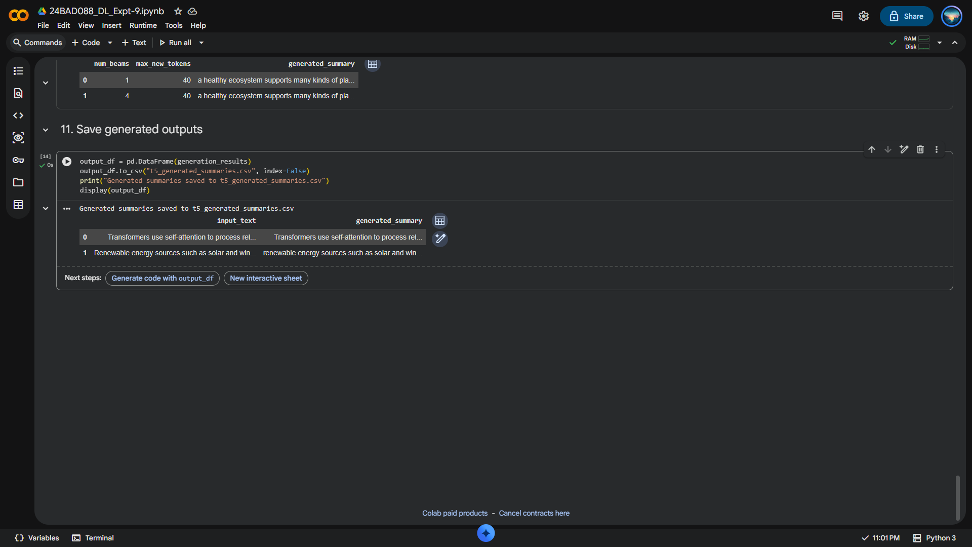

EXPECTED OUTCOME
Students will understand the architecture and applications of Transformer models in Natural Language Processing. They will learn to fine-tune a pretrained BERT model for text classification, preprocess textual data, and evaluate classification performance using appropriate metrics. Students will also develop a simple sequence-to-sequence text generation application using a pretrained Transformer model and analyze the quality and relevance of the generated outputs.

POST-LAB QUESTIONS (PROVIDE BRIEF ANSWERS TO THE FOLLOWING QUESTIONS)

1. What is the role of BERT in text classification?
BERT (Bidirectional Encoder Representations from Transformers) understands the contextual meaning of words by considering both left and right context. In text classification, BERT processes the input text and uses a classification layer to predict categories such as positive sentiment, negative sentiment, or spam.

2. Why is tokenization required before providing text to a Transformer model?
Tokenization converts input text into smaller units called tokens, such as words or subwords. These tokens are mapped to numerical IDs that the Transformer can process. Tokenization enables the model to represent text numerically and understand linguistic patterns.

3. What is the purpose of fine-tuning a pretrained BERT model?
Fine-tuning adapts a pretrained BERT model to a specific task using task-specific training data. It updates the model's parameters to improve performance on tasks such as sentiment analysis, spam detection, and text classification without training the model from scratch.

4. Mention any two evaluation metrics used for text classification.
Two evaluation metrics are accuracy and precision. Accuracy measures the proportion of correctly classified instances among all instances. Precision measures the proportion of correctly predicted positive instances among all instances predicted as positive. Both metrics help evaluate classification performance.

5. What is the role of the encoder and decoder in a sequence-to-sequence Transformer?
The encoder processes the input sequence and generates contextual representations using self-attention. The decoder uses these representations and previously generated tokens to produce the output sequence one token at a time. Together, they support tasks such as machine translation and text summarization.

6. What is the difference between text classification and text generation?
Text Classification | Text Generation
Assigns predefined labels to input text. | Produces new text based on input or context.
Example: Sentiment analysis. | Example: Story writing.
Models: BERT, DistilBERT. | Model: GPT.

7. How does the maximum output length affect text generation?
Maximum output length determines the number of tokens a model can generate. A shorter limit may truncate the response, while a longer limit allows more detailed output. However, longer outputs require additional computational resources and may contain unnecessary information.

8. Mention one real-world application of Transformer-based text classification and one application of text generation.
Text classification: Email spam detection uses Transformer models such as BERT to classify emails as spam or legitimate. Text generation: AI chatbots use models such as GPT to generate human-like responses to user questions, enabling automated customer support and conversational assistance.

SUGGESTIONS FOR DATASETS & MODELS
Datasets:
- IMDb Movie Reviews – https://huggingface.co/datasets/stanfordnlp/imdb
- GLUE Benchmark – https://huggingface.co/datasets/nyu-mll/glue
- SST-2 Sentiment Classification – https://huggingface.co/datasets/nyu-mll/glue

Pretrained Models:
- BERT Base Uncased – https://huggingface.co/google-bert/bert-base-uncased
- T5-small – https://huggingface.co/google-t5/t5-small

GitHub: https://github.com/Pradeep-Manikandan-1-D/24BAD088_DEEP_LEARNING_LAB
ASSESSMENT
Description | Max Marks | Marks Awarded
Pre Lab Exercise | 5
In Lab Exercise | 10
Post Lab Exercise | 5
Viva | 10
Total | 30
Faculty Signature

